Implementation process
According to the author's paper and ppt , we need to generate_synthetic_data.py, generate_real_data.py to generate the previous frame and current frame in the figure below, and then use the merge_datasets.py tools in deeptracking to mix them as a training set. Similarly, the same procedure can be used to generate the verification set.

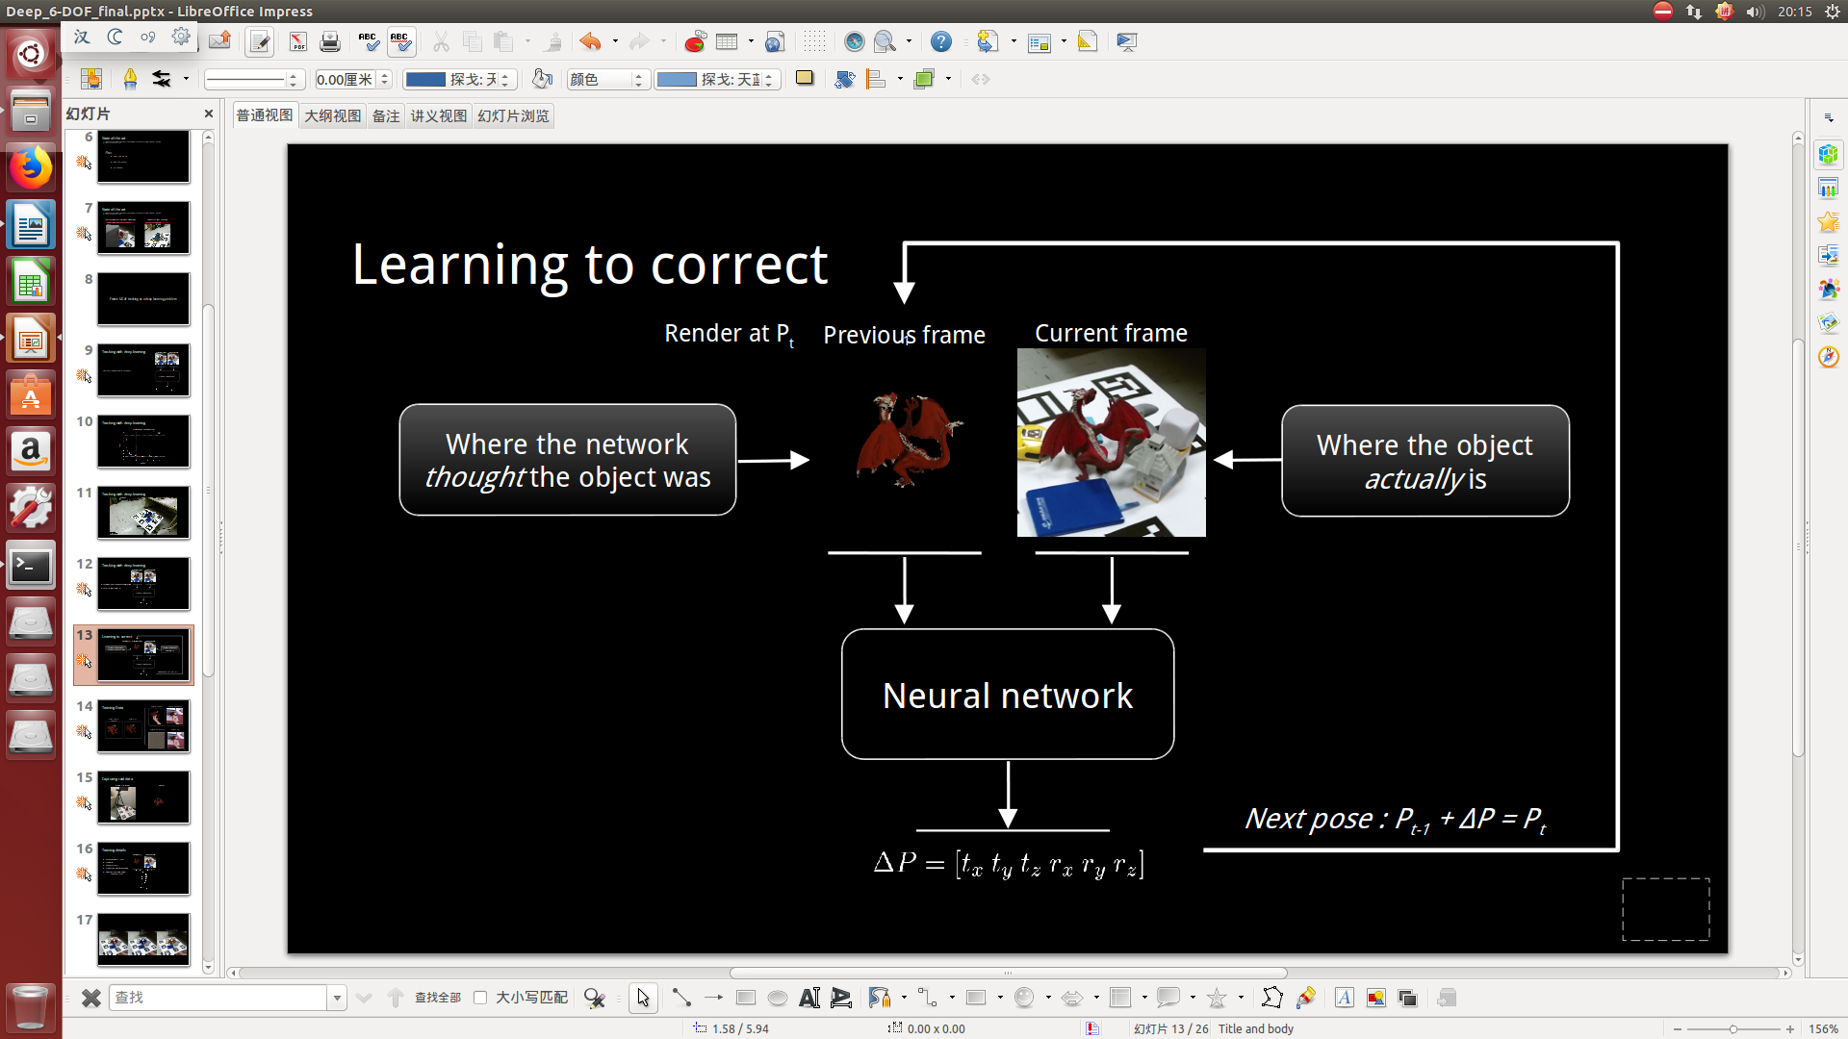
generate_synthetic_data.py Running Results:

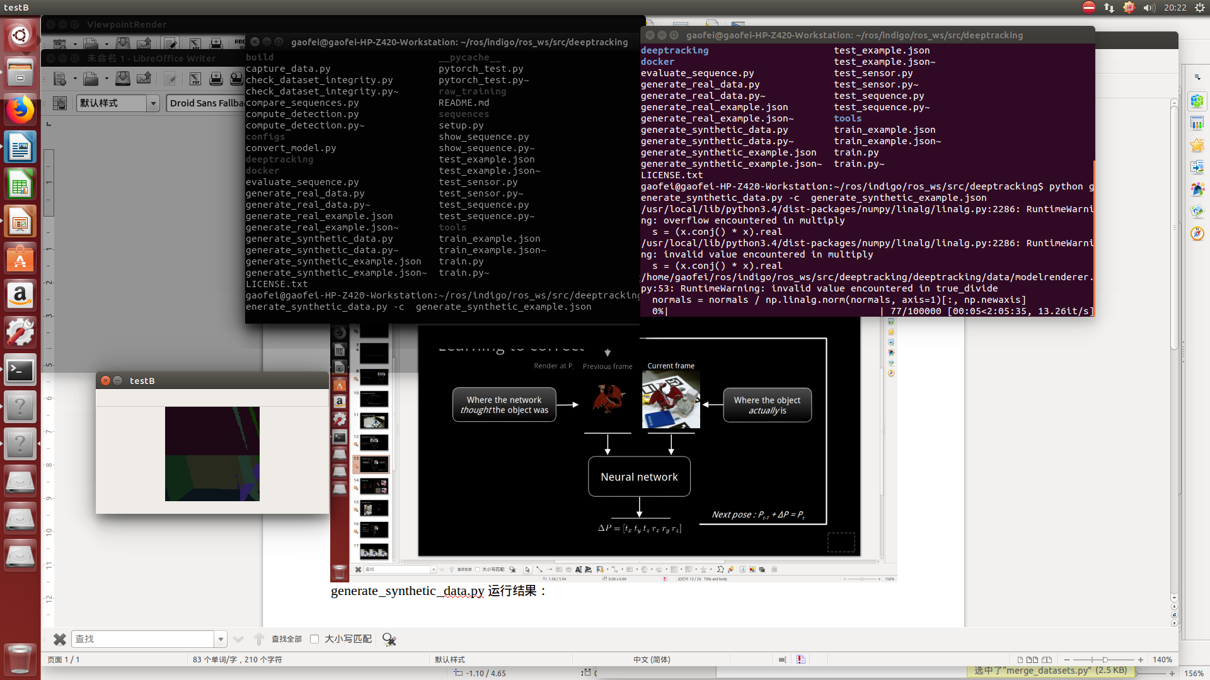
As shown in the figure, there will be overflow in the normal calculation in the dragon model. The resulting picture is very far from the paper. According to the paper, the picture should be a picture of the dragon with no background in Figure 1. For other models such as skull
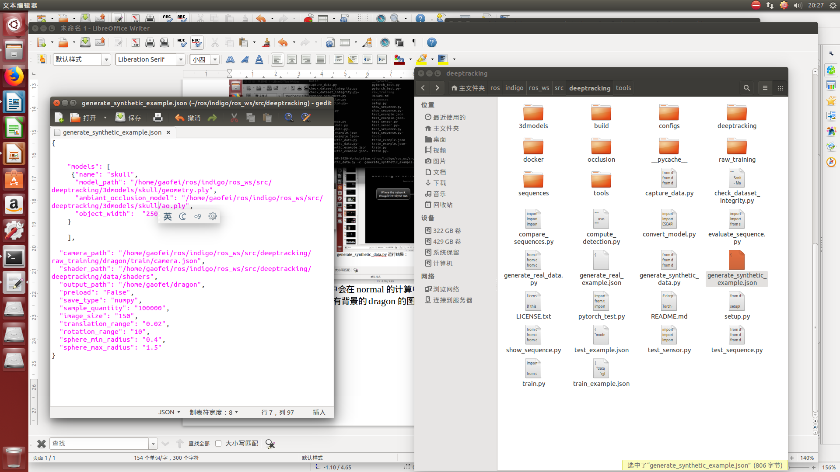
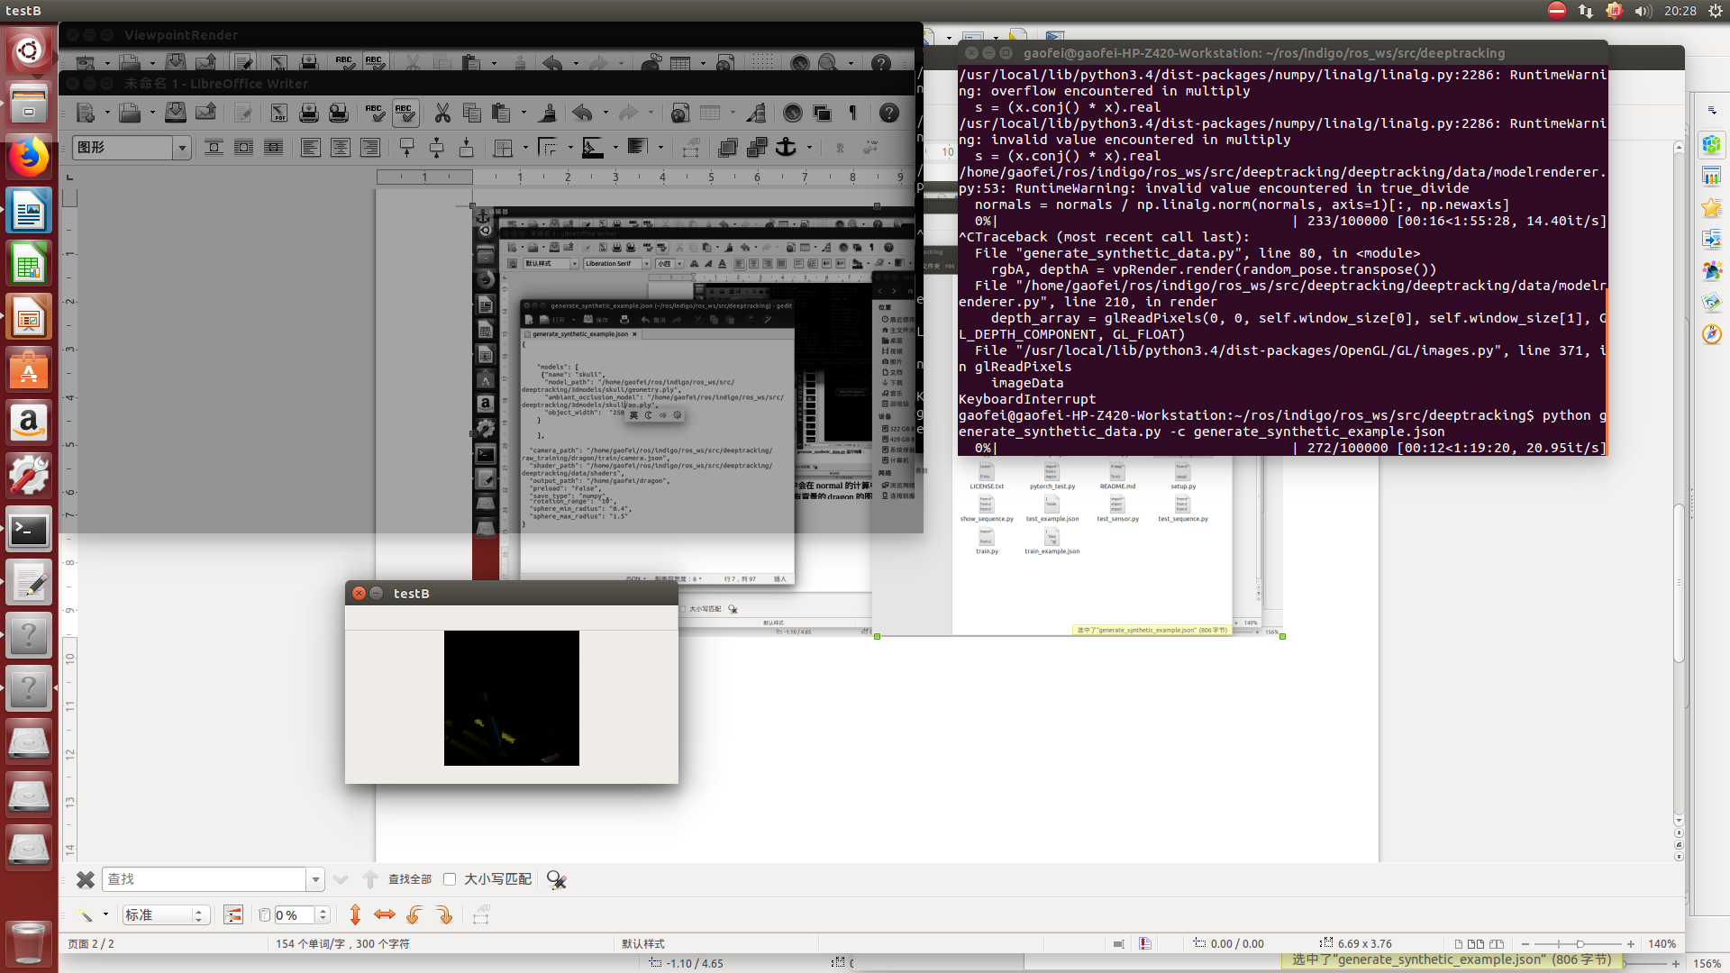
generate_real_data.py Demonstration result:
There is nothing wrong, but you can see that this should be a complete 3d model but seems it produce less than ideal results.

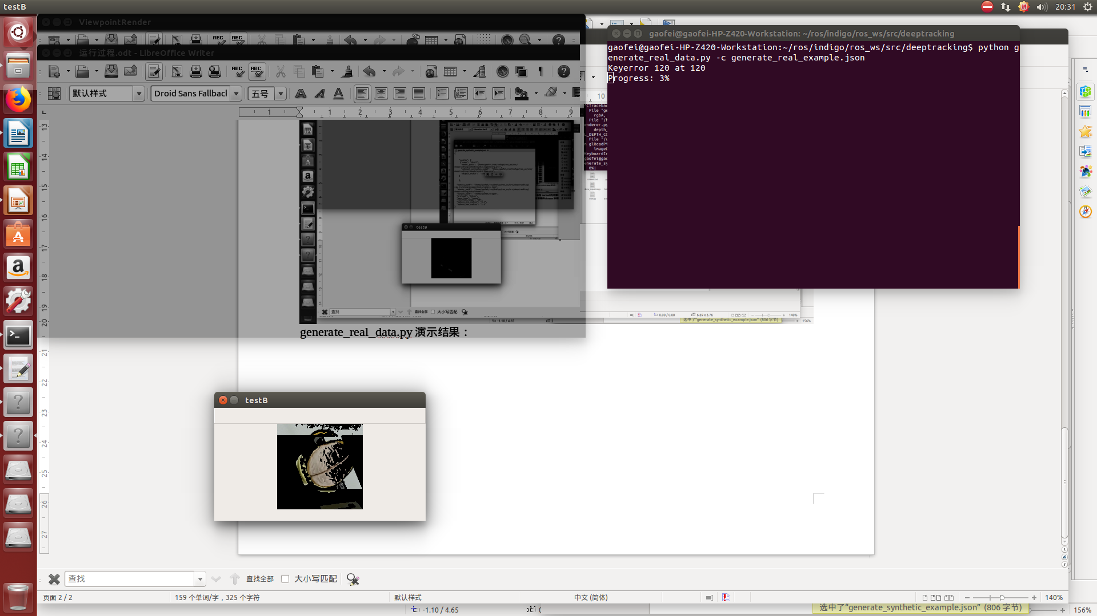
train.py results:
Just to be a small demonstration, my padding data is very small but the machine actually collapsed. Just to prove that the environment is indeed built correctly it is only the hardware constraints led to the results are not satisfactory.
Since the validation function requires well-trained model result data, I have not been able to demonstrate any training so can not show the validate part:
2018-01-29 20:55:35 __main __ [INFO] train.py:222 Setup Datasets
2018-01-29 20:55:35 __main __ [INFO] train.py:99 Setup Train: / home / gaofei / dragon
2018-01-29 20:55:36 __main __ [INFO] train.py:106 Computed mean: [1.18879998 2.31146669 0.65359998 -304.39163208 3.55537772
4.312222 3.11995554 -305.23696899]
Computed Std: [0. 0. 0. 0. 2.48835552 2.70862198
2.3448 1.06384277]
2018-01-29 20:55:36 __main __ [INFO] train.py:107 Setup Valid: / home / gaofei / skull
2018-01-29 20:55:36 __main __ [INFO] train.py:225 Setup Model
2018-01-29 20:55:41 __main __ [DEBUG] train.py:227 Backend: cuda
nn.Sequential {
[input -> (1) -> (2) -> (3) -> (4) -> (5) ->
(1): nn.Sequential {
[- (1) -> (2) -> (3) -> (4) -> (5) -> (6) -> (7) -> 10) -> (12) -> (13) -> (14) -> (15) -> output]
(1): nn.ParallelTable {
input
| `-> (1): nn.Sequential {
| [input -> (1) -> (2) -> (3) -> (4) -> output]
| (1): nn.SpatialConvolution (4 -> 24, 5x5)
| (2): nn.SpatialBatchNormalization (4D) (24)
| (3): nn.ELU (alpha: 1.000000)
| (4): nn.SpatialMaxPooling (2x2, 2,2)
|}
`-> (2): nn.Sequential {
[input -> (1) -> (2) -> (3) -> (4) -> output]
(1): nn.SpatialConvolution (4 -> 24, 5x5)
(2): nn.SpatialBatchNormalization (4D) (24)
(3): nn.ELU (alpha: 1.000000)
(4): nn.SpatialMaxPooling (2x2, 2,2)
}
... -> output
}
(2): nn.JoinTable
(3): nn.SpatialConvolution (48 -> 48, 3x3)
(4): nn.SpatialBatchNormalization (4D) (48)
(5): nn.ELU (alpha: 1.000000)
(6): nn.SpatialMaxPooling (2x2, 2,2)
(7): nn.SpatialConvolution (48 -> 48, 3x3)
(8): nn.SpatialBatchNormalization (4D) (48)
(9): nn.ELU (alpha: 1.000000)
(10): nn.SpatialMaxPooling (2x2, 2,2)
(11): nn.SpatialConvolution (48 -> 48, 3x3)
(12): nn.SpatialBatchNormalization (4D) (48)
(13): nn.ELU (alpha: 1.000000)
(14): nn.SpatialMaxPooling (2x2, 2,2)
(15): nn.View (-1, 2352)
}
(2): nn.Dropout (0.5, busy)
(3): nn.Linear (2352 -> 50)
(4): nn.ELU (alpha: 1.000000)
(5): nn.Linear (50 -> 6)
(6): nn.Tanh
}
2018-01-29 20:55:41 __main __ [SLACK] train.py:236 Train start at 2018/01/29 20:55:41
2018-01-29 20:55:43 __main __ [INFO] train.py:180 [100%]: Train loss: nan
2018-01-29 20:55:43 __main __ [INFO] train.py:182 Time / batch: 0.0005429645379384358h
2018-01-29 20:55:43 __main __ [SLACK] train.py:243 [Epoch 0] Train loss: 0 Val loss: nan
2018-01-29 20:55:43 __main __ [INFO] train.py:180 [100%]: Train loss: nan
2018-01-29 20:55:43 __main __ [INFO] train.py:182 Time / batch: 3.4365852673848473e-05h
2018-01-29 20:55:43 __main __ [SLACK] train.py:243 [Epoch 1] Train loss: 0 Val loss: nan
2018-01-29 20:55:43 __main __ [INFO] train.py:180 [100%]: Train loss: nan
2018-01-29 20:55:43 __main __ [INFO] train.py:182 Time / batch: 2.897653314802382e-05h
2018-01-29 20:55:43 __main __ [SLACK] train.py:243 [Epoch 2] Train loss: 0 Val loss: nan
2018-01-29 20:55:44 __main __ [INFO] train.py:180 [100%]: Train loss: nan
2018-01-29 20:55:44 __main __ [INFO] train.py:182 Time / batch: 3.191981050703261e-05h
2018-01-29 20:55:44 __main __ [SLACK] train.py:243 [Epoch 3] Train loss: 0 Val loss: nan
2018-01-29 20:55:44 __main __ [INFO] train.py:180 [100%]: Train loss: nan
2018-01-29 20:55:44 __main __ [INFO] train.py:182 Time / batch: 3.512461980183919e-05h
2018-01-29 20:55:44 __main __ [SLACK] train.py:243 [Epoch 4] Train loss: nan Val loss: nan
2018-01-29 20:55:44 __main __ [INFO] train.py:180 [100%]: Train loss: nan
2018-01-29 20:55:44 __main __ [INFO] train.py:182 Time / batch: 2.8053919474283855e-05h
2018-01-29 20:55:44 __main __ [SLACK] train.py:243 [Epoch 5] Train loss: nan Val loss: nan
2018-01-29 20:55:44 __main __ [SLACK] train.py:256 Train Terminated at 2018/01/29 20:55:44
2018-01-29 20:55:44 __main __ [SLACK] train.py:257 Total Epoch: 0
Best Validation Loss: 1000
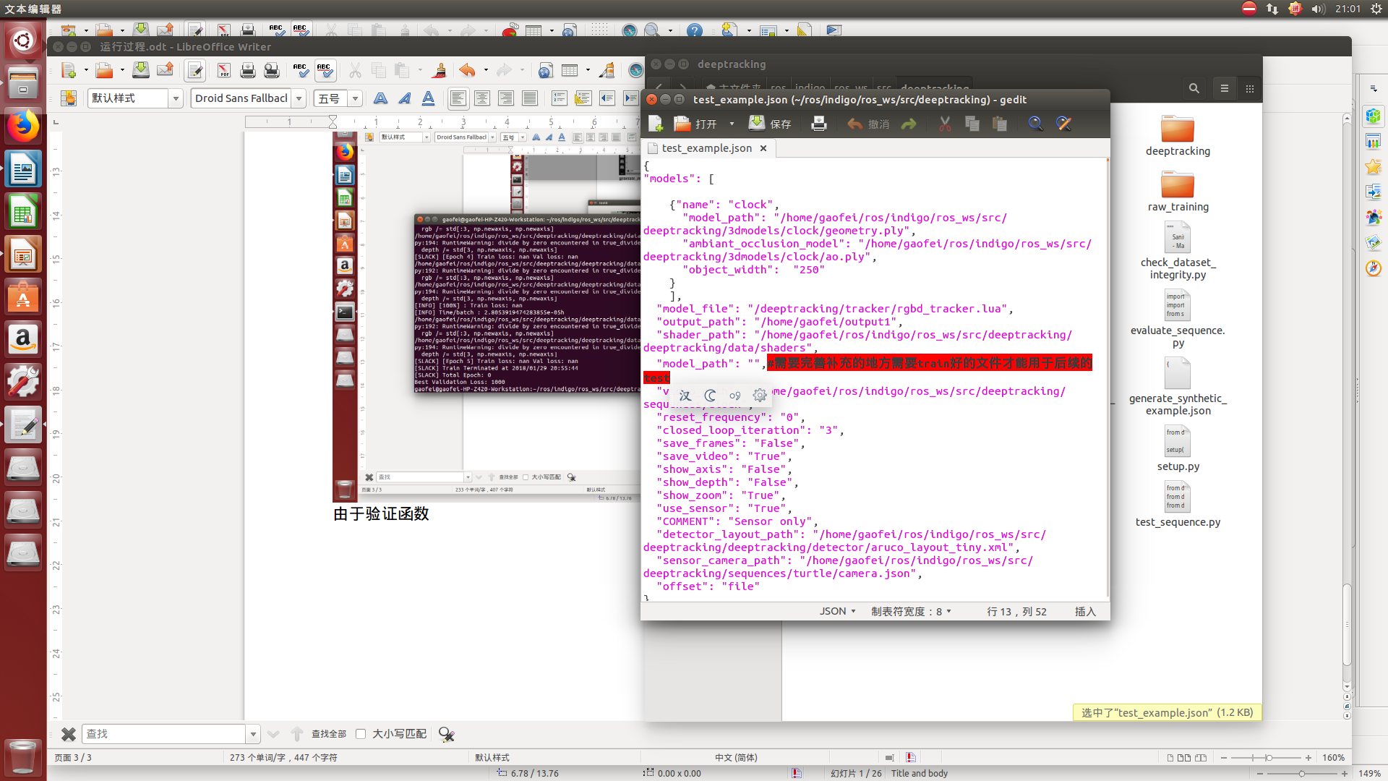
Training results can be seen up (text)and it is also the needs the in the up picture.
And tools can be generated tools csv documents will be displayed:

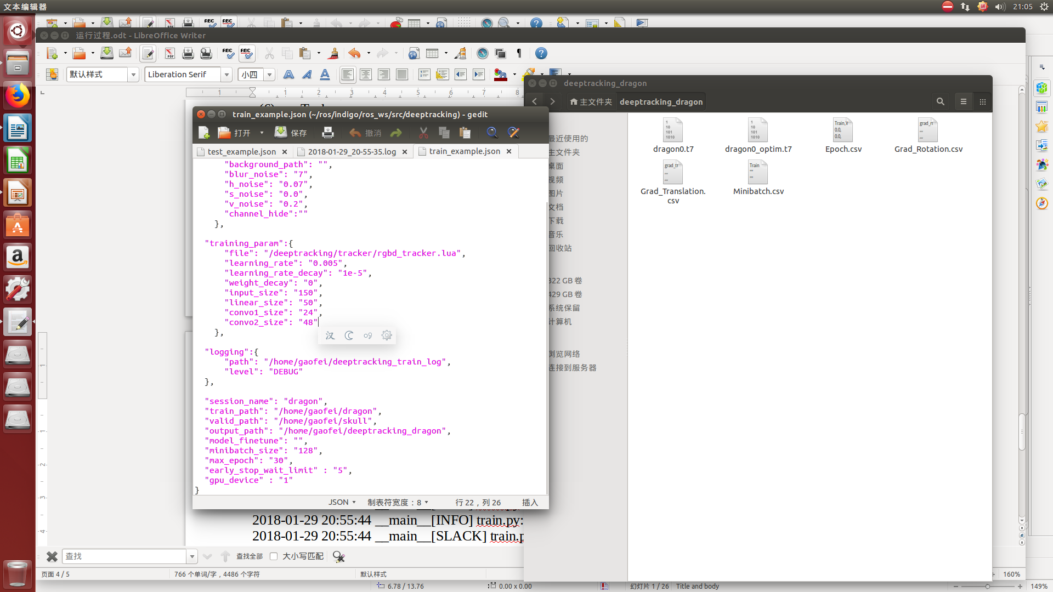
As you can see, occlution can also be used as a verification part because it is also a video file, so it matches what the author says to accurately track the occluded objects in real time with 6 free-throws, like a pair of fluoroscopy eyes. But my graphics card generated all the jagged things pictured here, which should produce the same thing as the one below. As to why there is such a problem, my opinion is caused by the computing power of the graphics card. The author's opinion is a code issue. Currently, he is carrying out the second phase of upgrade and is also handling my problem. https://github.com/lvsn/deeptracking/issues/9
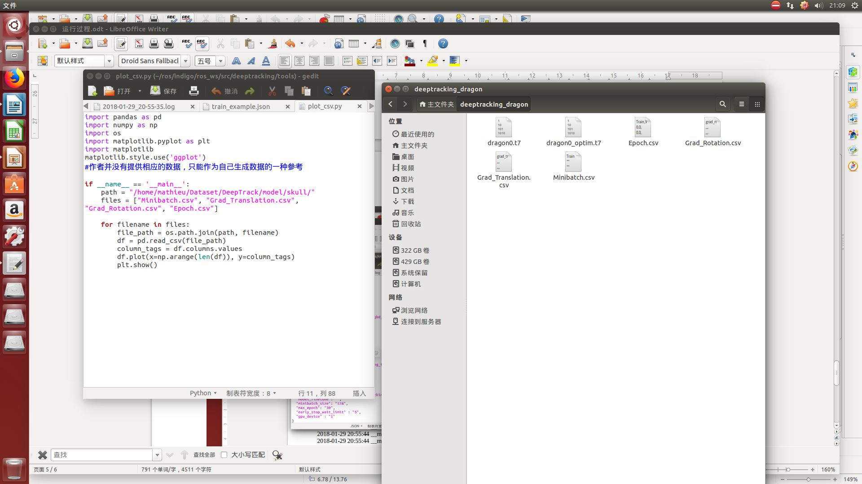
Please refer to my questions on the code in the project on the issue of the code, you can see the specific process of each step, mainly the graphics calculated a lot of non and beneficial phenomenon.
At this point all the code is introduced, the main environment is too difficult to build. I am currently looking for ways to build a docker image that frees me from the hassles of building environments. Thanks to this project, I have conceptualized the process of implementing a specific project, and because the results are suboptimal

My original, declined reproduced, if necessary, contact the author: Myzhencai@hotmail.com

